Group Assignment Report

Members:

|  |  |
| --- | --- |
| Student ID | Name |
| 814994 | Amrit Singh |
| 815290 | Karamveer Kaur |
| 815203 | Saanch |

Objective: A Python program to create a word sorting game. This program allows users to sort a list of random shuffled words.

Program Overview: This word-sorting game has been implemented in Python using various programming constructs such as classes, methods, loops, sorting algorithms and conditions. The program includes functionalities to shuffle the letters of a word, display the scrambled word in a box format, and compare the user's guess to the original word.

Code Implementation: The word sorting game includes a WordSortingGame class with several methods, such as shuffle_word, random_chooser, play_round, and play_game.

shuffle_word: This method shuffles the letters of a given word using sorting method and displays it in a box format.

randam_chooser: This method passes a random word from the word list.

play_round: This method plays a single round of the game, prompting the user to guess the original word from a shuffled word.

play_game: This method manages the entire game, allowing users to play multiple rounds until they choose to quit.

Screenshots of Code implication: -

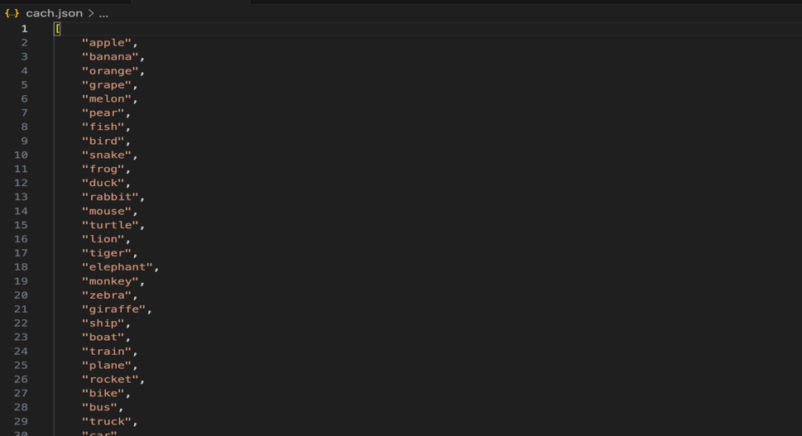

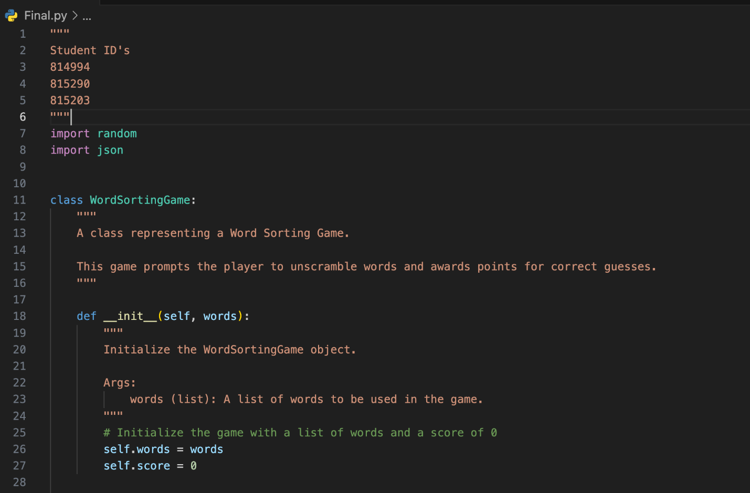

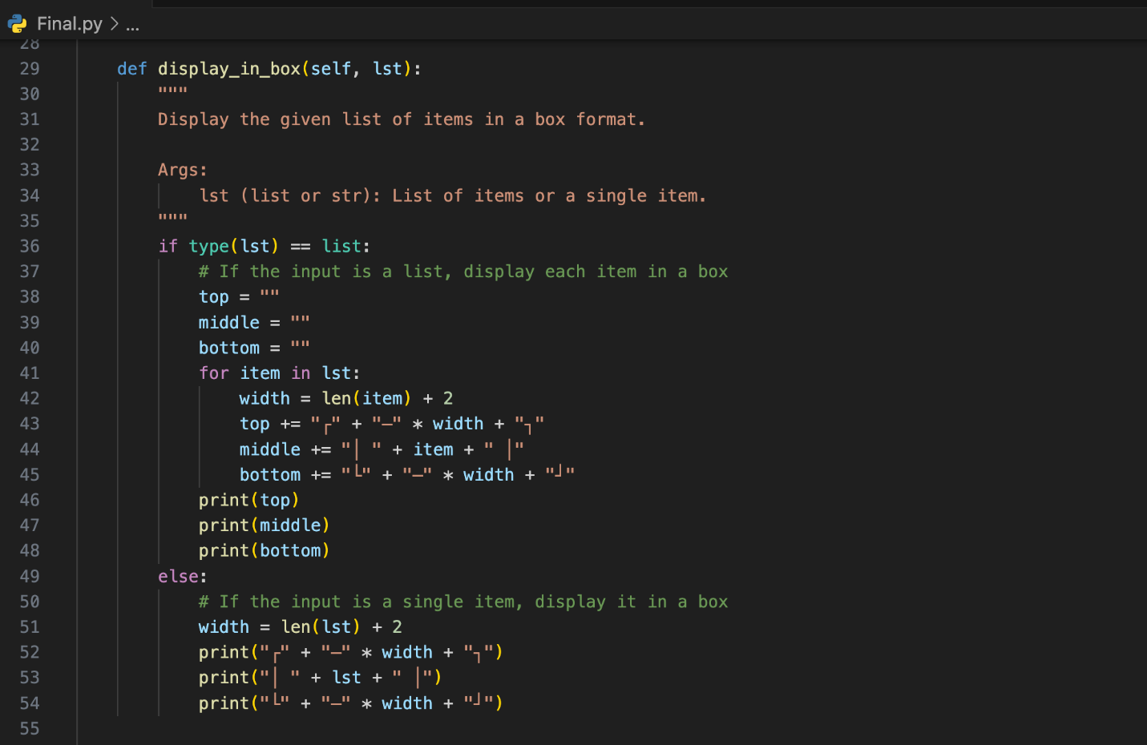

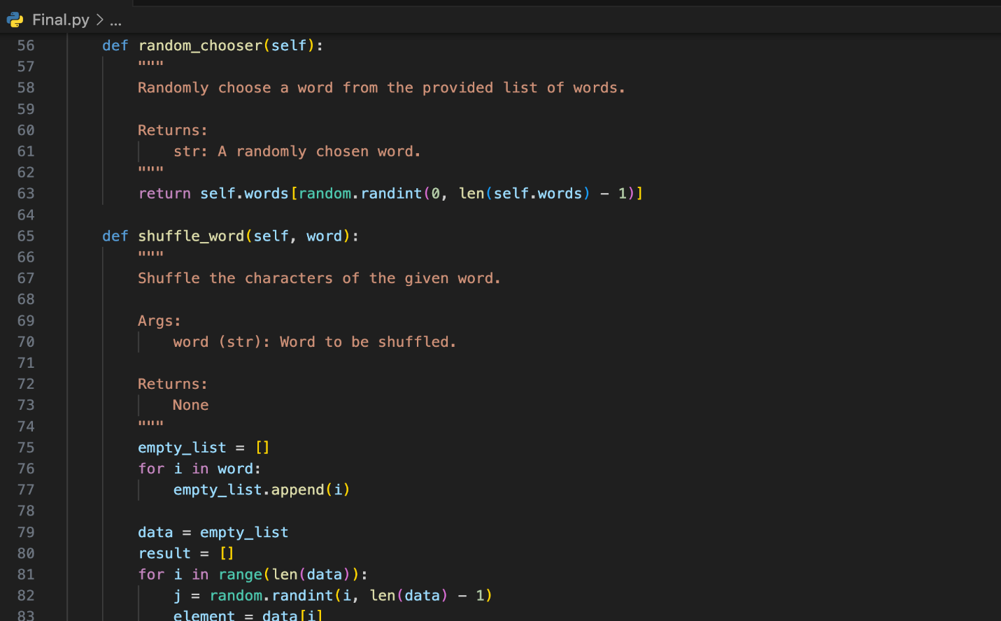

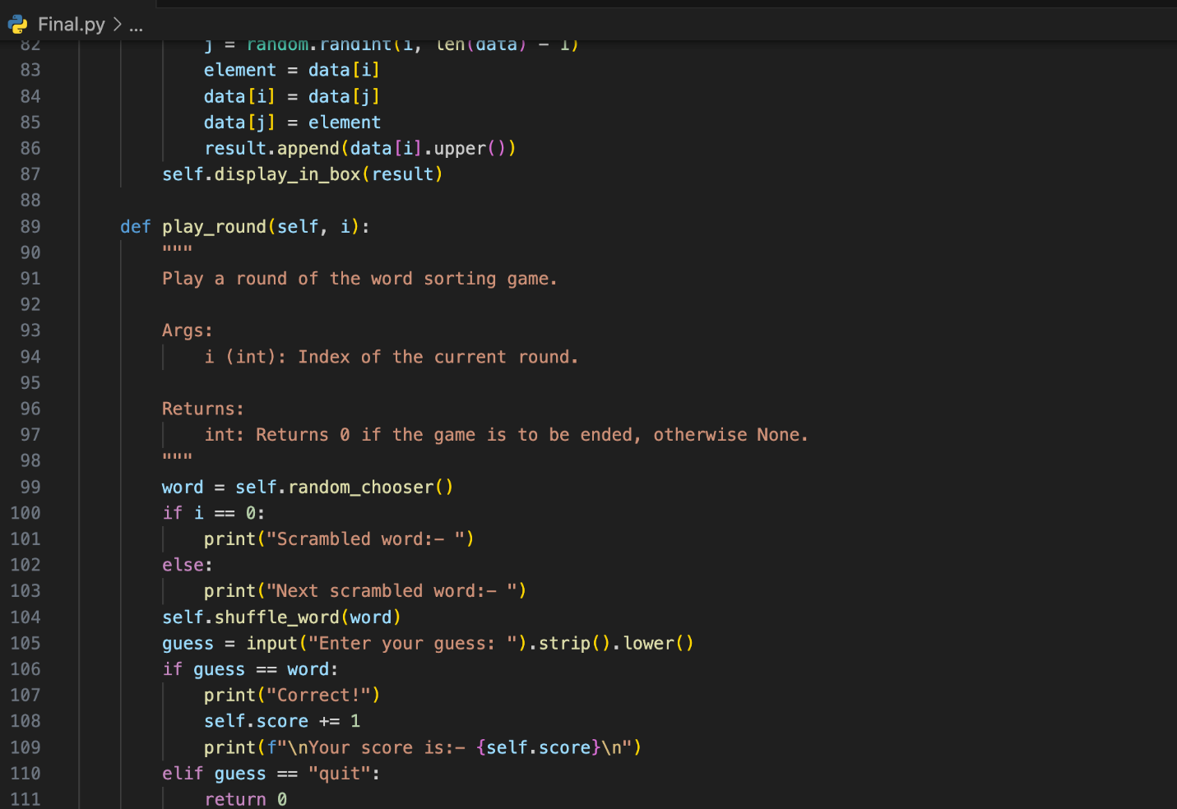

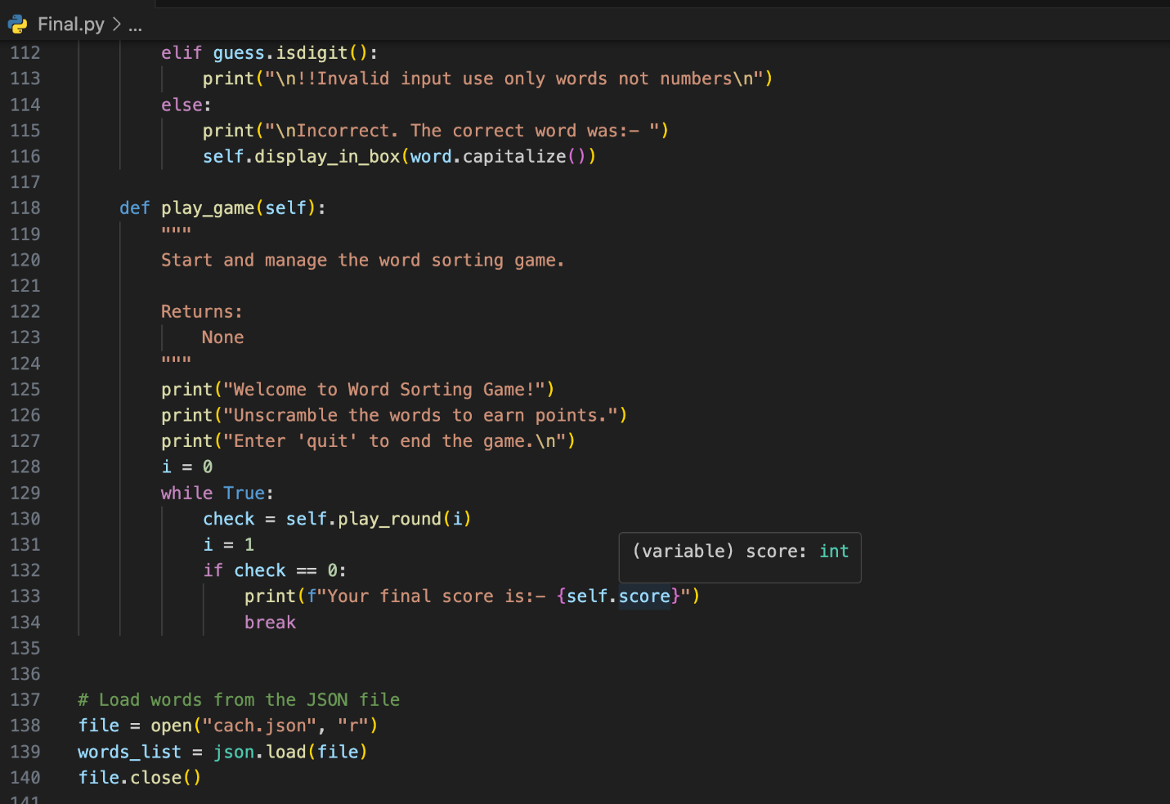

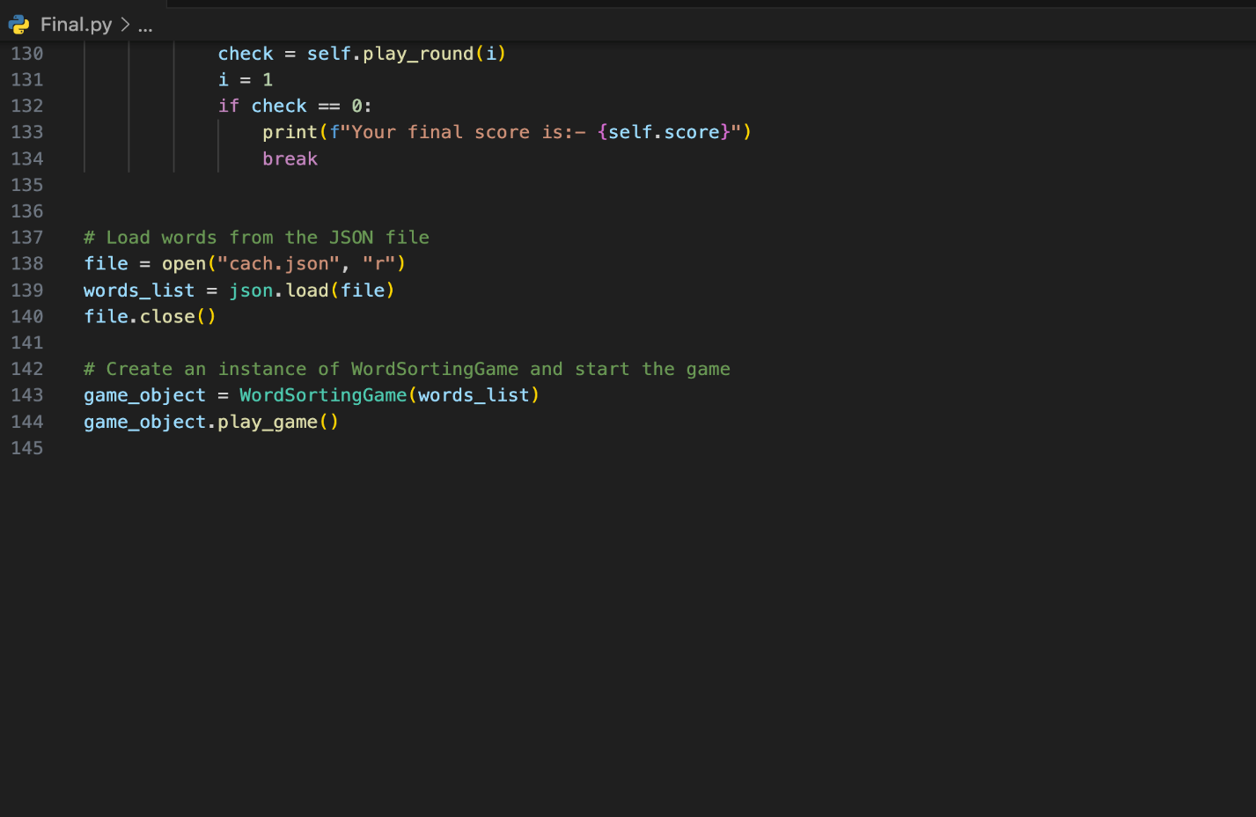

Output:-

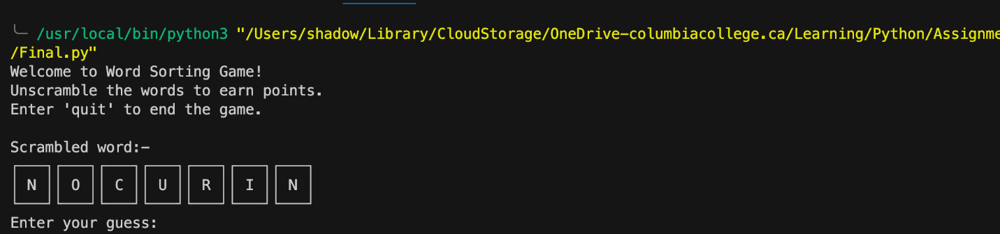

User Interface: The system provides a user-friendly interface with the following options:

Quit: To exit the program.

Enter your guess: Sorted word.

Developer Notes: The code is designed to handle various user inputs and provides appropriate error messages for invalid inputs. The program runs continuously until the user chooses to quit.

Conclusion: This concludes the overview of the Word Sorting Game implemented in Python. The game provides a fun and engaging way to test one's vocabulary and spelling skills, with opportunities for further enhancement, such as adding time limits, score multipliers, or hints.

The word sorting game is a simple and entertaining way to challenge oneself and improve vocabulary and spelling skills. With further enhancements, the game can become a valuable tool for language learning and development.